Jenkins Exercises

# Exercise 1: Freestyle Job - Windows File Transfer Automation

**Objective:** Automate file transfer between two directories on a Windows machine.

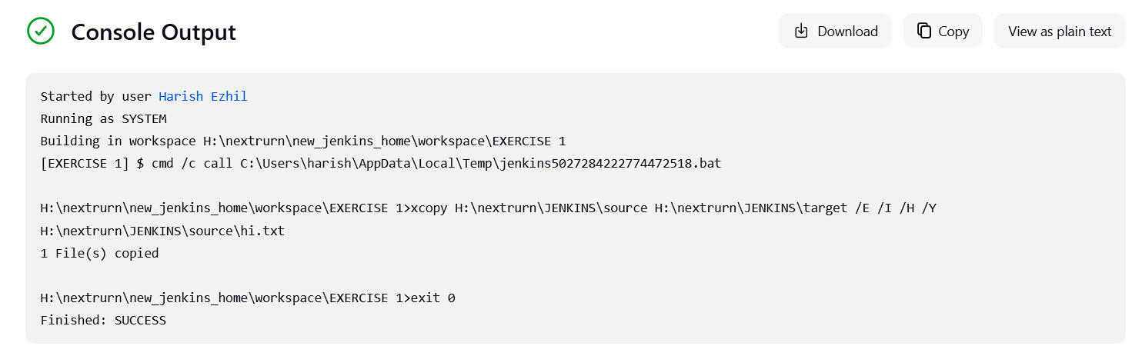

# Exercise 2: Freestyle Job - Build and Deploy a JavaScript Project

**Objective:** Build and deploy a JavaScript-based web project.

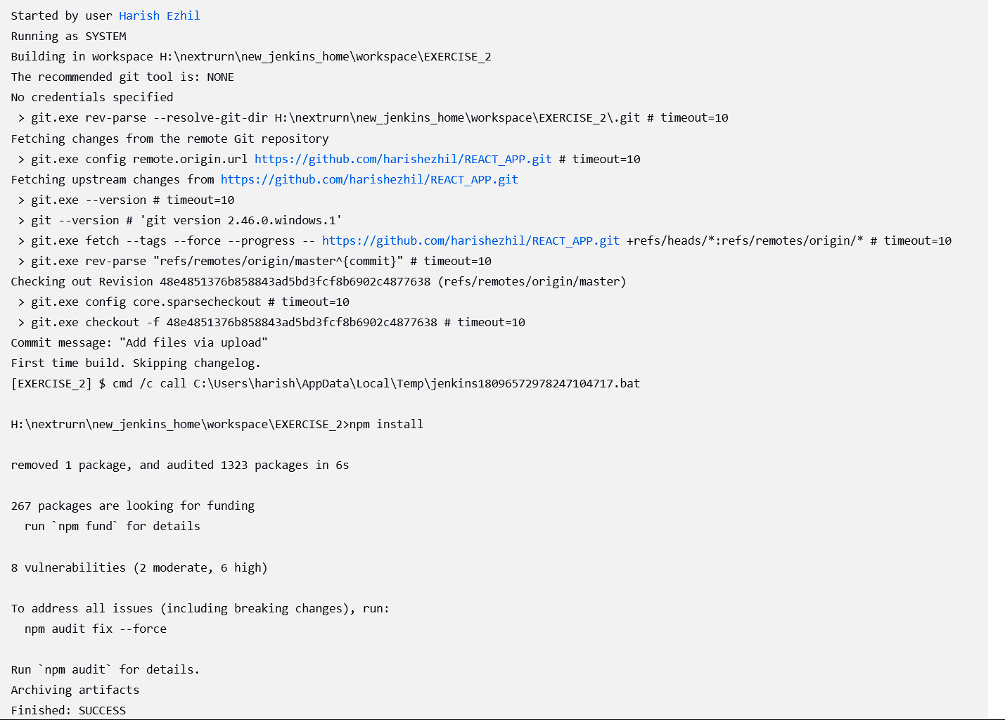

# Exercise 3: Freestyle Job - Flask Application Deployment

**Objective:** Automate the deployment of a Flask application.

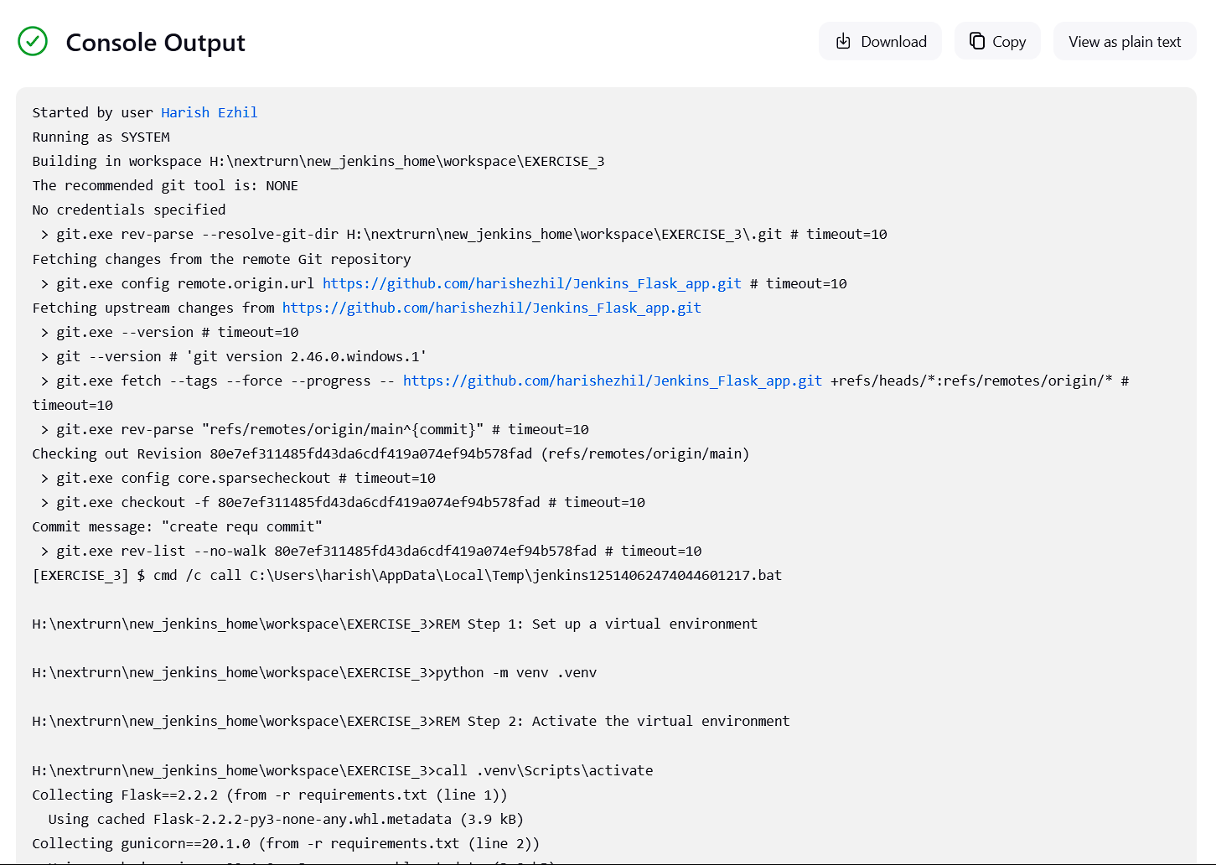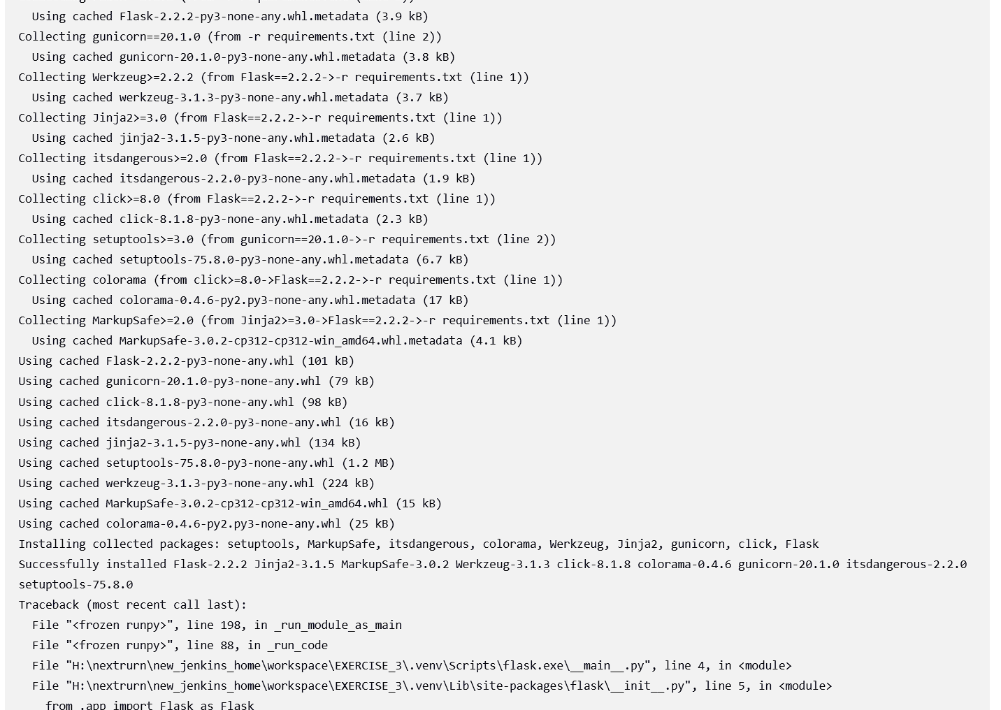

# Exercise 4: Pipeline Job - End-to-End CI/CD for a React Application

**Objective:** Implement a CI/CD pipeline for a React web application. 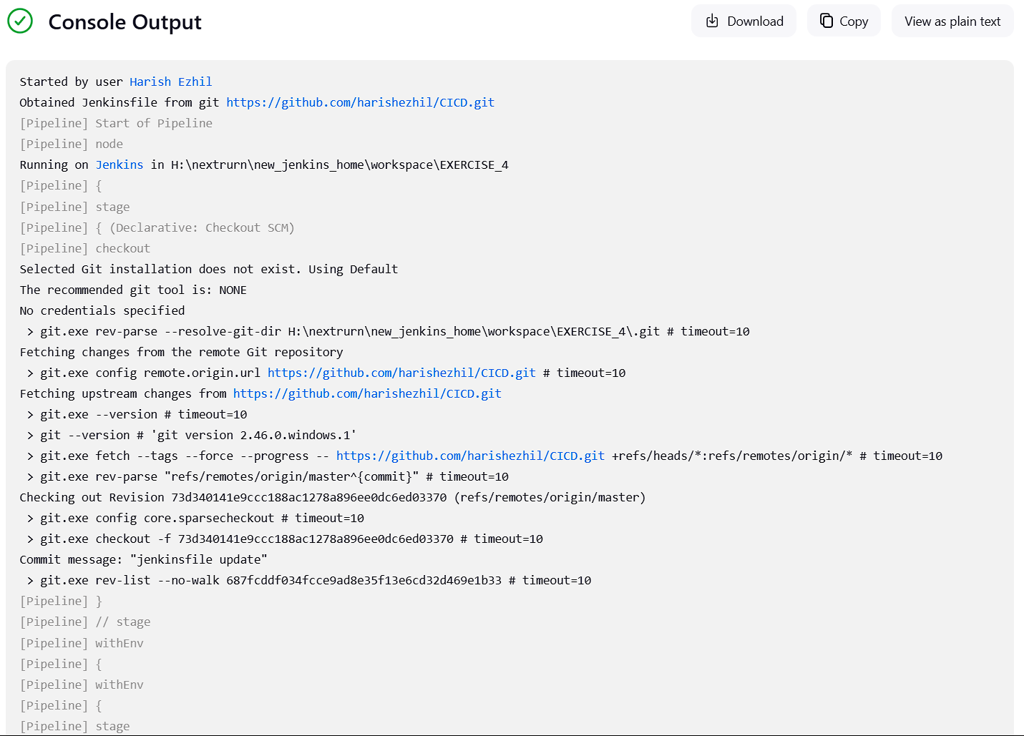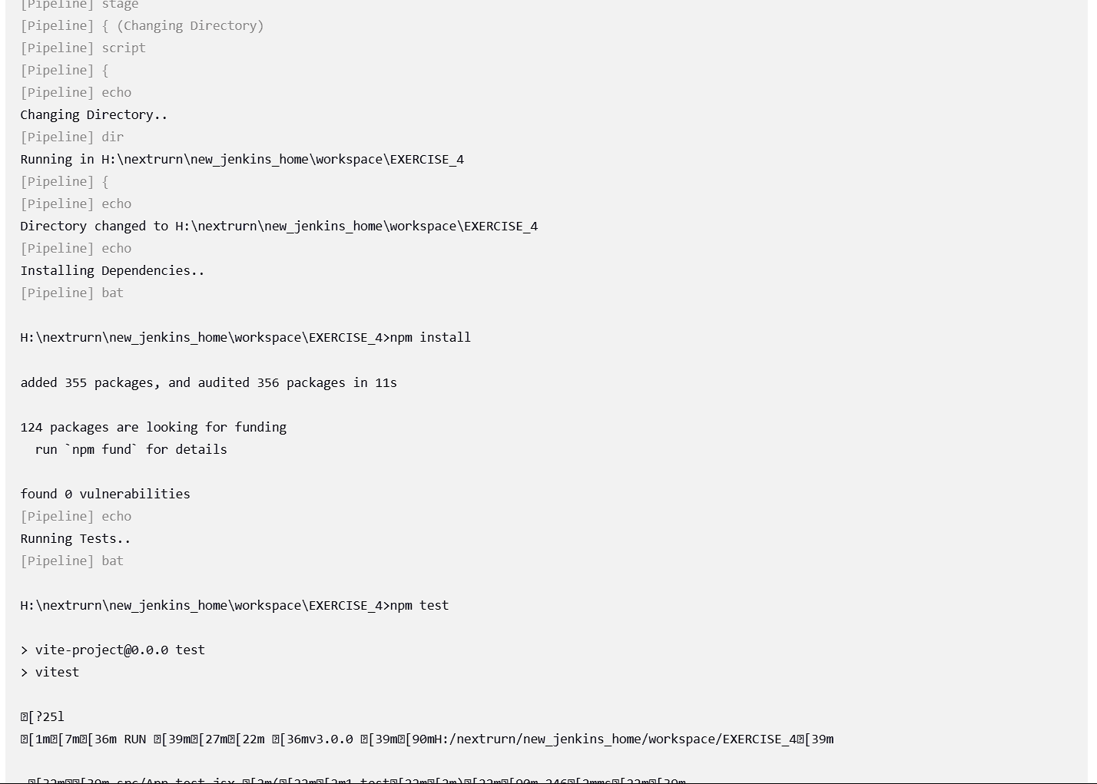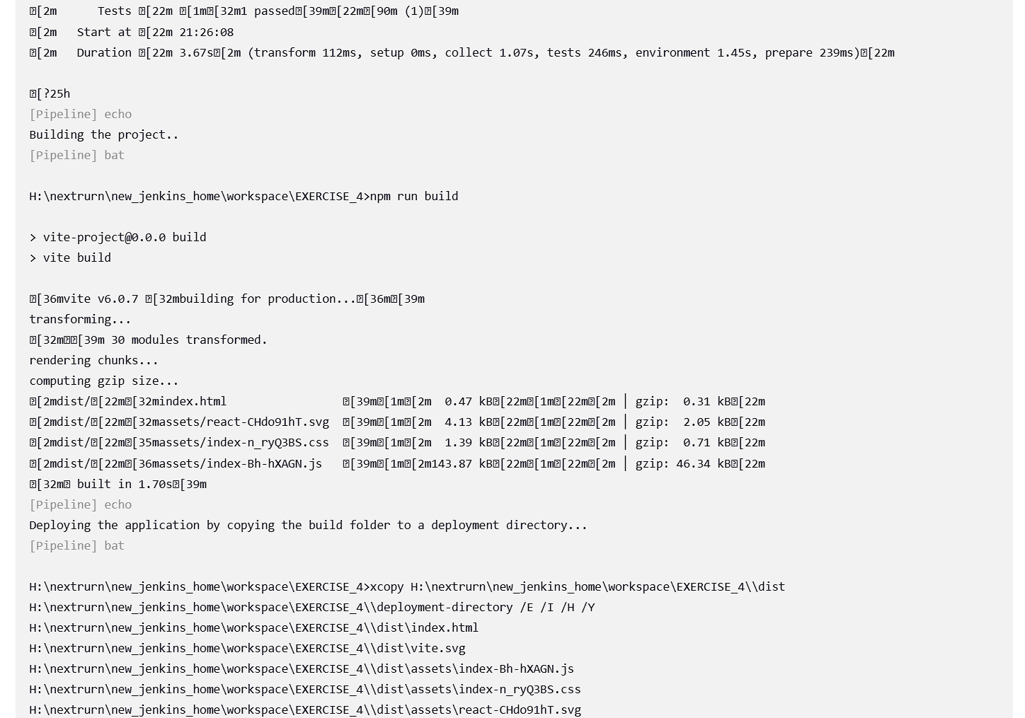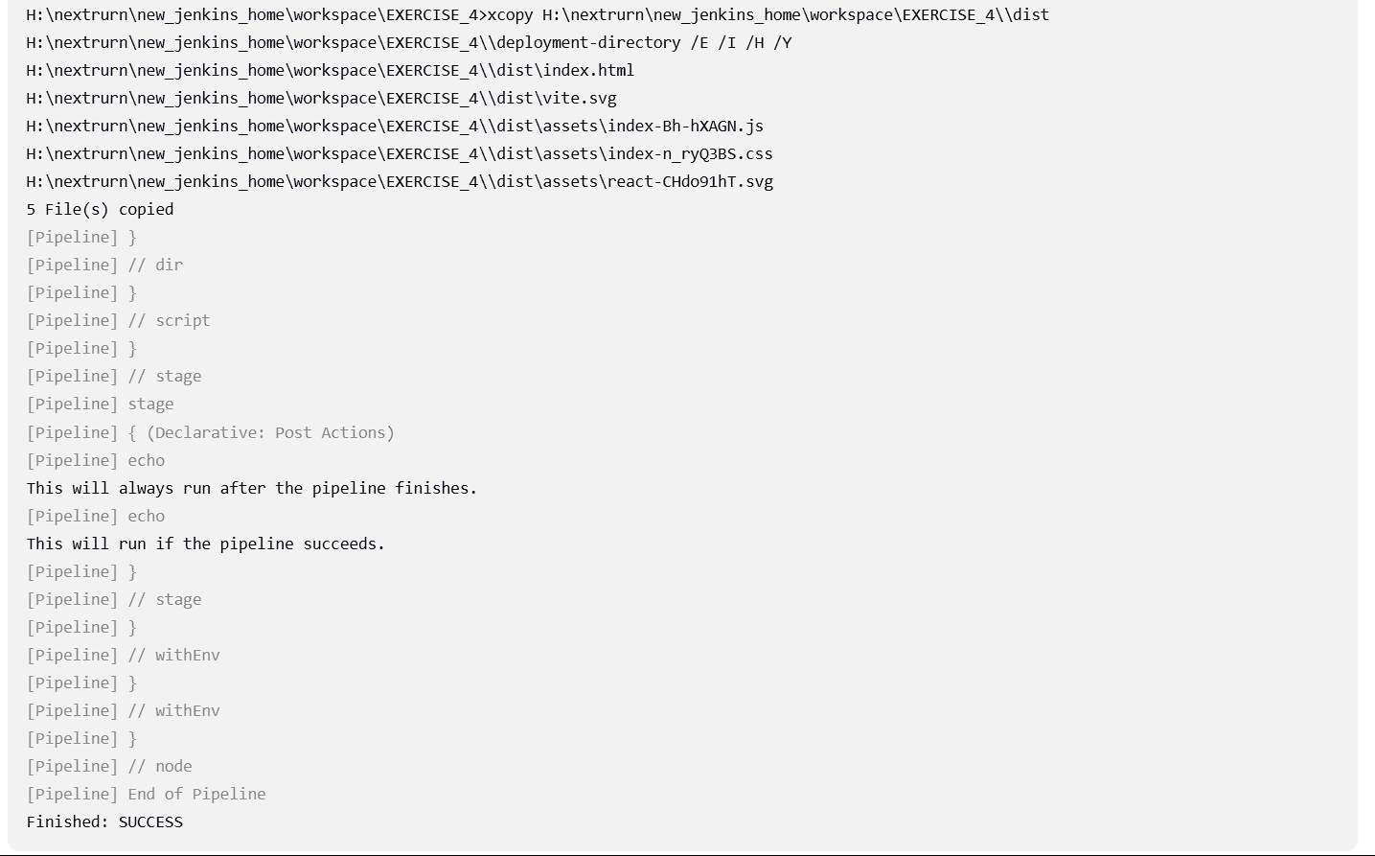

# Exercise 5: Pipeline Job - Deploy a Flask Application with Gunicorn

**Objective:** Automate the deployment of a Flask application with Gunicorn on Windows.

